CLIMATE INDICATORS FACTSHEET
A systematic assessment of climate-driven change across key ocean indicators, combining observational records and model projections to inform MPA management and conservation planning.
Mafia Island MPA
Last updated: 02 June 2026
Next issue: xx 2027
Keywords: Sea surface temperature, marine heatwaves, degree heating weeks, salinity, climate projections, CMIP6
Produced by: ClimPA Project : WP:3

Overview
This factsheet presents headline climate indicators for Mafia Marine Park, drawing on four decades of satellite-derived and reanalysis data. Each headline indicator follows a consistent structure: ecological relevance and justification, a summary of observed trends, and a forward-looking section covering projected future conditions under climate change scenarios.
The indicators are organised to build progressively from physical ocean conditions to chemical and biological responses providing a comprehensive baseline for adaptive MPA management.
The technical document and scripts used to derive the indicators are avaible on the GitHub repository here: xx

Indicators In This Series
01: Sea surface temperature | 03: Ocean Acidification | 05: Rainfall and runoff
02: Sea level rise | 04: Cyclone activity

Sea Surface Temperature
NOAA OISST v2.1 | OAA Coral Reef Watch Virtual Station 1985 to 2024 | CMIP6 Projections

Relevance & justification
ECOLOGICAL SIGNIFICANCE | MANAGEMENT RELEVANCE
Sea surface temperature is the primary driver of coral bleaching, the most visible and economically significant climate impact on reef ecosystems. At Mafia Island, SST governs the timing and intensity of seasonal productivity, larval dispersal windows, and the physiological stress thresholds of reef-building corals and associated biodiversity. | Long-term warming trends and the increasing frequency of marine heatwaves directly inform bleaching alert systems, seasonal closure decisions, and the placement of climate refugia within the MPA. Degree heating weeks from NOAA CRW provide the operational metric used globally for bleaching prediction and response.
DATA RATIONALE | DERIVED VARIABLES
NOAA OISST v2.1 provides daily 0.25-degree resolution blended satellite and in-situ SST from 1981 to present, offering the longest consistent satellite-era record available for Mafia Island. The CRW virtual station adds the operationally validated degree heating week product derived from the same data stream. | Four derived variables are presented alongside raw SST: marine heatwave events (Hobday et al. 2016), SST anomalies relative to the 1985 to 2005 baseline, seasonal climatology shift between early and recent periods, and NOAA CRW degree heating weeks with bleaching alert area classifications.
CLIMATE PROJECTIONSCMIP6
CMIP6 is the current generation of coordinated climate model experiments underpinning the IPCC Sixth Assessment Report. Projection scenarios inform decadal MPA planning including refugia placement, zoning reviews and restoration site selection. Derived variables include ensemble median SST anomaly under SSP2-4.5 and SSP5-8.5 through 2100, projected annual degree heating week exceedance events (DHW ≥ 8°C weeks) and projected shifts in the bleaching season window across current, mid-century and end-century periods.

Indicator summary-SST
Mean SST at Mafia Island has warmed from 27.46°C (1985 to 2005 baseline) to 27.88°C in the recent period (2010 to 2025), a statistically significant trend of +0.165°C per decade. Marine heatwave activity is elevated with 129 recorded events, including a longest single event of 124 days and peak intensity reaching 1.4°C above the 90th percentile threshold.
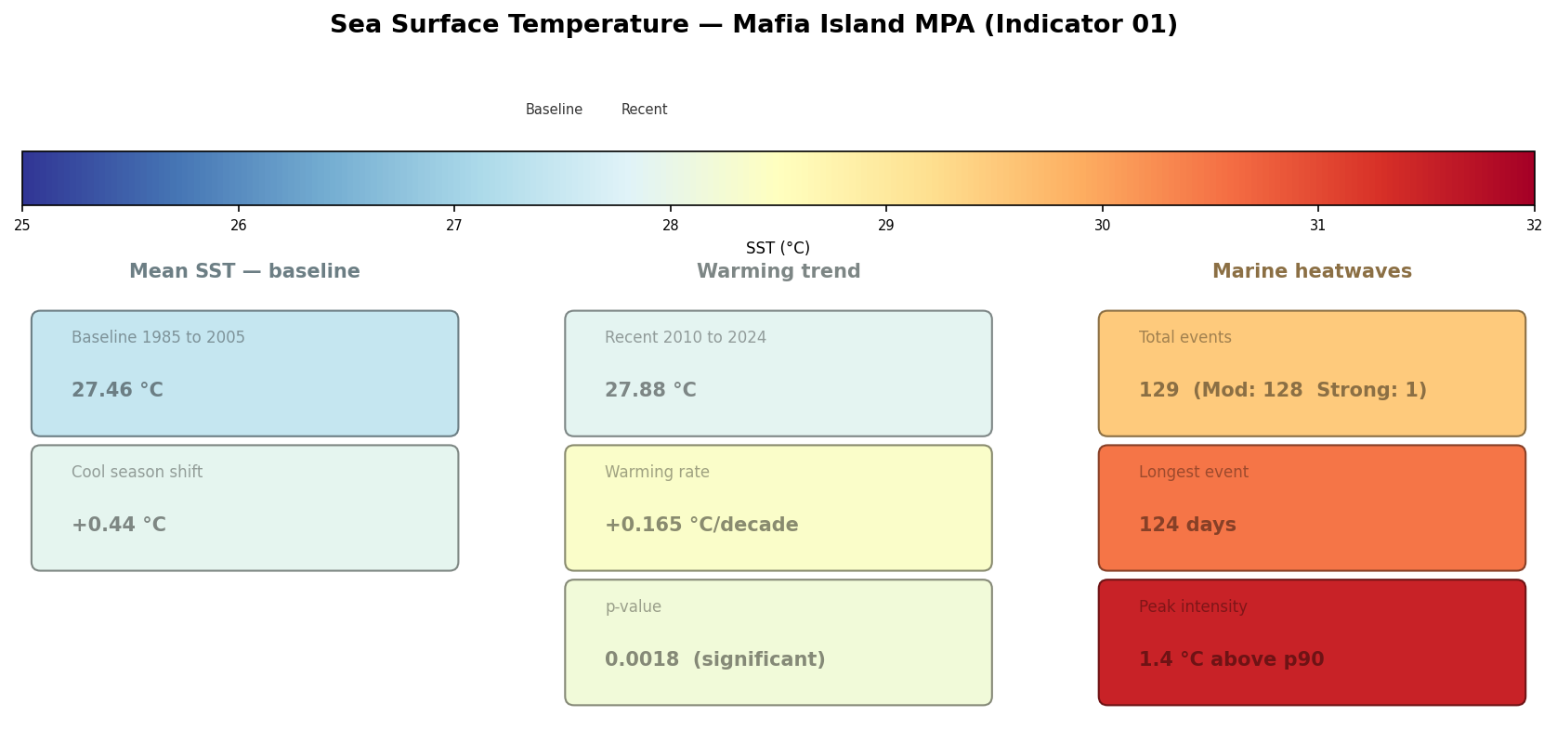
Figure 1 Sea surface temperature indicators for Mafia Island MPA showing baseline mean SST (1985 to 2005), recent warming trend (2010 to 2024), and marine heatwave characteristics derived from NOAA OISST v2.1 daily observations.

Past conditions (1985 to 2005)
The 40-year SST record confirms a sustained and statistically significant warming trajectory at Mafia Island, with the long-term trend and episodic thermal anomalies clearly visible across both the time series (Figures 2) and monthly anomaly record (Figures 3). The 1998 El Niño emerges as the dominant historical thermal event, driving the most severe bleaching on record, while the post-2005 period shows a progressive shift toward persistently above-baseline conditions that distinguishes recent decades from the reference period.

BASELINE MEAN SST  27.46 °C  Mean SST averaged over the 1985 to 2005 baseline period, representing the reference state against which all subsequent anomalies are measured. | SEASONAL RANGE  ~5 °C  Mafia Island experiences a pronounced seasonal cycle with warm peaks in February to April above 29 degrees C and a cool winter trough in July to August below 25 degrees C, driven by the East African Coastal Current.
1998 BLEACHING EVENT  DHW ~5  The 1998 El Nino drove the most severe bleaching on record across the Western Indian Ocean. DHW values of 4 to 5 degrees C-weeks caused mass mortality at Mafia Island, confirming bleaching onset well below the conventional 8 degrees C-week threshold. | WARMING TREND  +0.17 °C/dec  A statistically significant warming trend of +0.166 degrees C per decade (p = 0.0025) is detectable across the full 40-year record, consistent with broader Indian Ocean warming patterns.

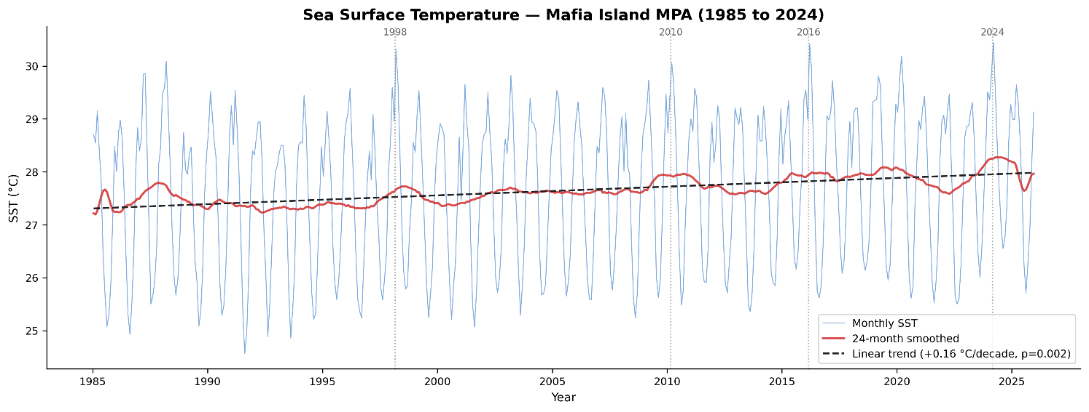
Figure 2 Monthly sea surface temperature at Mafia Island MPA (1985 to 2024) with 24-month smoothed trend and linear warming rate of +0.16°C per decade (p = 0.002). Source: NOAA OISST v2.1

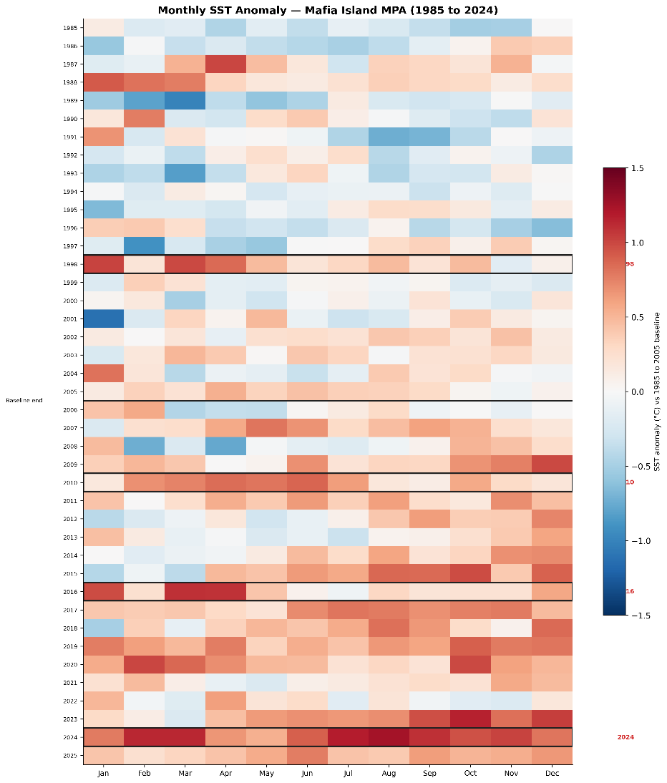
The 1998 El Niño emerges as the dominant historical thermal event, driving the most severe bleaching on record, while the post-2005 period shows a progressive shift toward persistently above-baseline conditions that distinguishes recent decades from the reference period.

The anomaly record reveals a clear shift from predominantly neutral to negative conditions during the baseline period toward persistently positive anomalies from 2010 onwards, with warm months now spanning the full seasonal cycle rather than isolated events. The 1998 El Niño produced the most intense basin-wide anomaly of the record, affecting all months uniformly, while the 2016 and 2024 events show a stronger concentration of extreme warmth in the first and final quarters of the year. The progressive reddening of the heatmap (figure 3) from the mid-2000s onwards is consistent with the measured warming trend and indicates that above-baseline thermal conditions have become the new seasonal norm at Mafia Island.
Figure 3 Monthly SST anomaly relative to the 1985 to 2005 baseline, Mafia Island MPA. Source: NOAA OISST v2.1.

Present Temperature Regime (2006-2025)
The present period is characterised by a marked intensification of thermal stress across all metrics. Seasonal climatology has shifted uniformly upward by 0.25 to 0.54°C across all months (Figure 4), while marine heatwave frequency and duration have increased sharply, with 2024 recording over 270 heatwave days and mean event duration exceeding 44 days (Figure 5). DHW accumulations now regularly breach the severe bleaching threshold of 8°C weeks, with the 2024 event reaching 16°C weeks, the highest on record, accompanied by sustained Alert Level 2 conditions at the CRW Tanzania virtual station (Figure 6).
RECENT MEAN SST (2010 TO 2024)  27.88 °C  Mean SST over the most recent period is 0.42 degrees C above the 1985 to 2005 baseline, consistent with the observed warming trend and accelerating in recent years. | 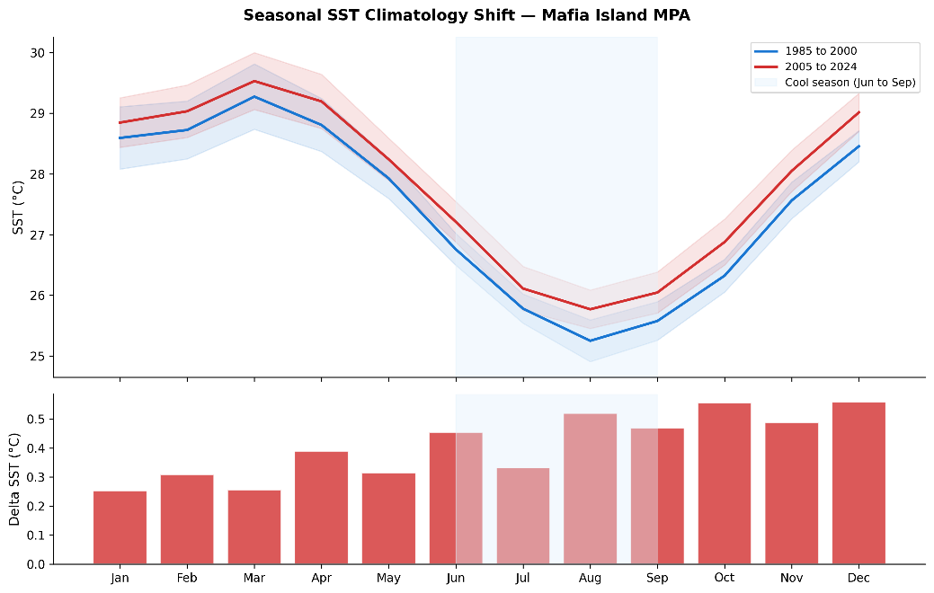  Figure 4 Seasonal SST climatology shift at Mafia Island MPA comparing early (1985 to 2000) and recent (2005 to 2024) periods, with monthly delta SST.
COOL SEASON WARMING SHIFT
+0.44 °C
The cool season (June to September) has warmed by 0.44 degrees C comparing early and recent periods. Reduced seasonal cooling diminishes the thermal refuge that corals rely on between warm seasons.
MARINE HEATWAVE EVENTS  122  122 discrete marine heatwave events detected since 1985, totalling 121 Moderate and 1 Strong category events. Frequency and duration have increased markedly since 2015, with 2024 recording the longest single event at 124 days. | 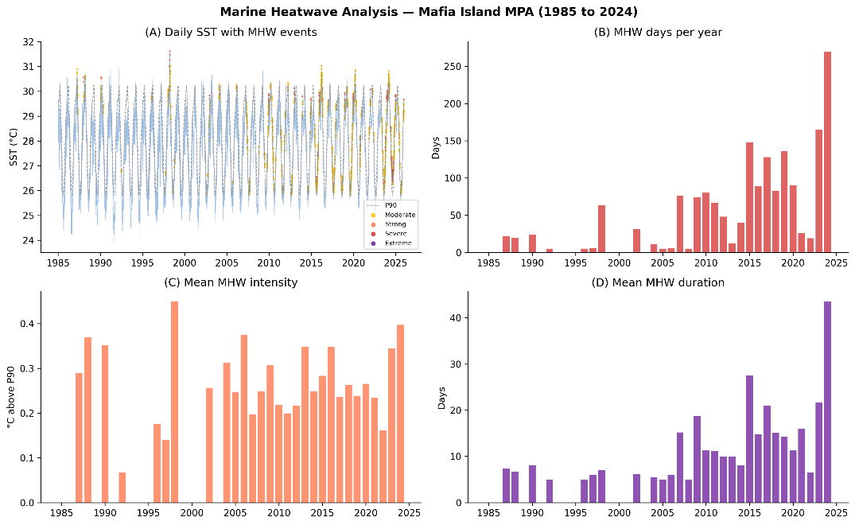  Figure 5 Marine heatwave analysis at Mafia Island MPA (1985 to 2024) showing daily SST with MHW event classifications (A), annual MHW days (B), mean annual intensity (C), and mean event duration (D).
PEAK THERMAL STRESS
1.4 °C
Maximum MHW intensity of 1.4 degrees C above the 90th percentile threshold. The 2016 and 2024 events produced the highest DHW accumulations in the record, exceeding 10 degrees C-weeks with documented bleaching and mortality.

The loss of cool season relief combined with escalating thermal stress events signals that Mafia Island reefs are operating with progressively reduced recovery capacity between bleaching episodes (Figure 8), a trajectory that CMIP6 projections indicate will xxx under both moderate and high emission scenarios

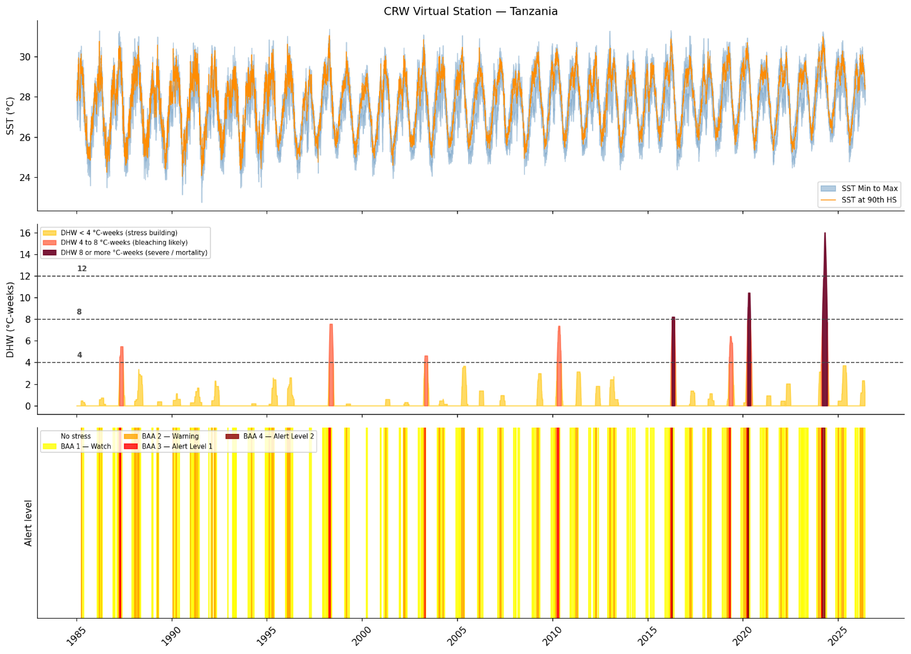
Figure 6 NOAA Coral Reef Watch virtual station record for Tanzania (1985 to 2024) showing daily SST range, degree heating weeks by bleaching alert threshold, and bleaching alert area classifications.

Future climate regime CMIP6..

Sea Level Rise

References
Hobday, A. J., et al. (2016). "A hierarchical approach to defining marine heatwaves." Progress in oceanography 141: 227–238.

